SAFE DRIVE: REAL TIME DROWSINESS DETECTION

BRIGITTE MARY A
DHARSHINI A

Abstract:
Driver drowsiness is a key cause of traffic accidents, typically resulting in slower response times and compromised judgment. In this study, we developed a real-time monitoring with facial behaviour to early recognition the drowsiness and yawning. The system monitors the closing time of the eyes and pattern of mouth movement to detect fatigue-related signals and issue a beep to help keep drowsy drivers alerted. The proposed system was designed to be a low computational cost, unobtrusive solution which can work in embedded environment. Experimental validations show the method works in different scenarios, and hence qualifies as a scalable safety feature for intelligent transportation systems.
Keywords – Driver Monitoring, Drowsiness Detection, Yawning Detection, Fatigue Analysis, Road Safety, Real-Time Alert System.
I.INTRODUCTION:
Ensuring safety on our roads continues to be a major challenge, with driver fatigue quietly playing a significant role in causing accidents. Many drivers fail to notice the early signs of fatigue, often realizing they are too sleepy only when it’s almost too late. Everyday distractions, like using a mobile phone, navigating traffic, or simply dealing with long drives, can gradually increase tiredness, which is often ignored or underestimated. Most vehicles on the road today lack built-in systems to detect drowsiness, and relying solely on manual observation or self-awareness can be unreliable, leaving drivers and passengers vulnerable to accidents.
This project aims to develop a system capable of detecting driver tiredness instantly by using advanced machine learning techniques. The system monitors facial indicators, such as blinking patterns and yawns, to recognize signs of tiredness and issue immediate warnings. This method helps lower the likelihood of accidents and encourages safer driving practices. The objective is to build a system that is user-friendly, efficient, and suitable for real-world applications, combining technology with human safety to make every journey safer for everyone on the road. It is a small step toward a bigger goal: making roads safer through smarter, more accessible technology.
II.LITERATURE REVIEW:
Detecting when drivers become fatigued has increasingly become a critical concern in road safety research. Extended periods of driving can significantly impact a driver's level of alertness. Earlier detection methods focused on biological indicators, like brain activity (EEG) or heartbeat monitoring,
which although precise, necessitated specialized equipment and physical contact with the driver less than ideal scenario for routine use. As technology progressed, researchers started to investigate computer vision as a non-intrusive alternative.

One of the most significant contributions to vision-based drowsiness detection was made by “Soukupová and Čech introduced the Eye Aspect Ratio (EAR) for blink detection” who proposed the concept of the Eye Aspect Ratio (EAR). Their method involves calculating the ratio of vertical to horizontal eye landmarks to identify blinks and extended periods of eye closure. This straightforward yet powerful geometric method established the basis for numerous real-time fatigue monitoring systems that depend exclusively on facial landmarks.

The system developed in this project applies these principles by capturing the driver’s face with a camera and computing EAR and MAR based on the identified facial landmarks, and activates an alert when signs of drowsiness or yawning are identified. It is straightforward, effective, and engineered to operate seamlessly on embedded platforms rendering it a viable solution for actual driving scenarios.

III.METHODOLOGY:

The Safe Driver system is designed to unobtrusively monitor drivers. Utilizing only a camera, it observes indicators of fatigue like prolonged blinks or yawns by detecting slight variations in facial expressions. When the system recognizes that the driver is showing signs of tiredness, it gently issues a warning to help regain their focus. This system is quick, lightweight, and engineered to operate seamlessly in real time, rendering it an effective safety partner while driving.

1.Video Capture: A standard webcam is used to record the driver’s face in real time. It is strategically placed to guarantee clear visibility of the eyes and mouth, key areas for monitoring signs of tiredness.

2.Facial Landmark Extraction: Each frame undergoes processing through Mediapipe's Face Mesh model, which maps 468 points on the face. These points allows the isolation of particular regions surrounding the eyes and mouth. The model operates efficiently on a CPU, rendering it appropriate for embedded systems.

3.Eye Aspect Ratio (EAR): EAR provides a simple way to determine if the eyes are open or closed. It measures specific points around the eye, and a reduction in the vertical distance while the horizontal distance remains constant indicates that the eyes are closing.

When EAR stays low for a few frames, it’s a strong sign the person might be feeling drowsy.

EAR = ((p2-p6) + (p3-p5)) ÷ 2(p1-p4)

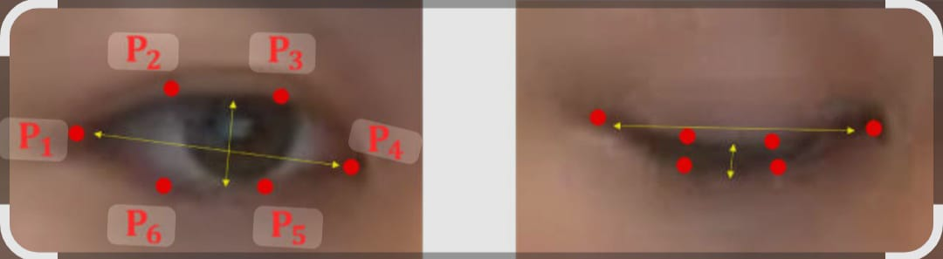
Fig.1. Eye Fatigue Estimation
EAR = Average vertical distance of eye / Horizontal distance of eye.

Vertical Eye Distance: The measurement between the upper and lower eyelid landmarks.
Horizontal Eye Distance: The measurement between the inner and outer corners of the eye.

If eyes are open → EAR is high
If eyes are closed → EAR is low

4. Mouth Aspect Ratio (MAR): Mouth Aspect Ratio (MAR): MAR helps detect yawning by measuring how widely the mouth opens. It compares the vertical stretch of the lips to their horizontal width. If the mouth stays wide open for a moment, MAR goes up — and that usually means the person is yawning, another sign of fatigue.

MAR = ((p2 -p8) + (p3-p7) + (p4-p6)) ÷ 2(p1-p5)

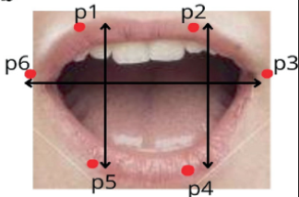
Fig.2.MAR Estimation

MAR = Average vertical distance of the mouth / Horizontal distance of the mouth.

Vertical Mouth Distance: The measurement between the upper and lower points of the mouth.
Horizontal Mouth Distance: The measurement between the left and right corners of the mouth.

If mouth is closed or open → MAR is low
If mouth is open wide or yawing → MAR is high

4.Alert Activation: If the EAR or the MAR consistently surpasses its threshold, the system activates an audible alert
through Pygame. This alert aims to encourage the driver to refocus and prevent possible accidents.
This rule-based methodology guarantees quick and dependable performance without the need for extensive deep learning training or large datasets. The system is modular, lightweight, and tailored for real-time implementation on embedded hardware.
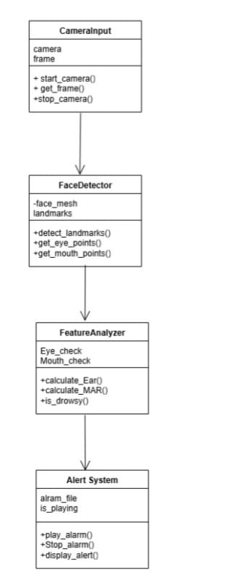
Fig.3.Class Diagram

IV.SYSTEM ARCHITECTURE:

The Safe Driver system is built to be simple, effective, and intuitive. At its core, the system constantly monitors the driver’s face to detect early signs of fatigue and issues alerts to prevent accidents. The system follows clear workflow, starting from capturing the video feed to triggering an alert if fatigue is detected.

The Safe Driver System proposals are carried out with several stages.

1. Input: A standard camera continuously record of the driver’s face. This video feed acts as the primary input for all subsequent analyses.

2. Preprocessing: Each frame is transformed into grayscale to decrease computational demands and enhance the accuracy of landmark detection.

3. Feature Extraction: The system identifies facial landmarks using Dlib’s 68-point detector. From these, points around the eyes and mouth are selected to analyze driver behavior.

4. Drowsiness Metrics: Two essential metrics are measured: Eye Aspect Ratio (EAR) for monitoring eyelid closure, and the Mouth Aspect Ratio (MAR) for detecting yawns. Both ratios are derived from geometric relationships among facial landmarks

5. Classification: Threshold-based detection and CNN models are used to classify drowsiness.

6. Alerts: Upon detecting drowsiness, the system initiates an immediate alert either an audible sound or vibration to assist the driver in regaining focus.

Tools and Technologies Utilized:
1.OpenCV: Employed for video capture, frame preprocessing, and image manipulation.

2.Dlib: Offers the 68-point facial landmark detector utilized for recognizing eye and mouth regions

3.Python: Acts as the primary programming language for module integration and logic execution.
4.NumPy: Utilized for efficient numerical operations, such as measuring distance required to compute EAR and MAR.

5.Pygame: Manages audio playback for alert generation when drowsiness is detected.

6.Basic Camera Hardware: A standard webcam is employed to consistently observe and record the driver's facial expressions in real time.
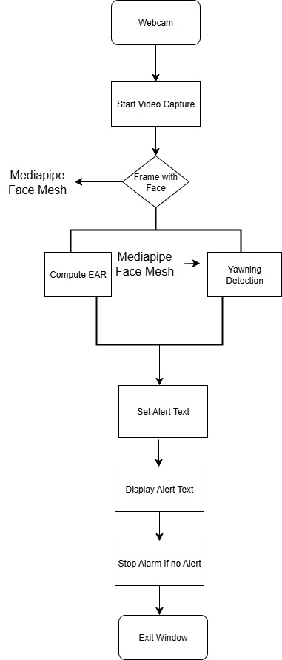

Fig.4.Architecture Diagram

V. DEPLOYMENT AND PERFORMANCE:

1.Deployment Setup: The Safe Driver system is configured on a standard laptop equipped with a 720p webcam. It functions entirely on the CPU without needing internet access, which allows it to run offline in real time. The software stack includes Python 3.10, OpenCV handling image analysis, Dlib to identify facial landmark, NumPy to perform mathematical computations, and Pygame to trigger alerts.

2.Real-Time Operation: The system processes video input at approximately 15-30 frames per second, depending on the laptop’s hardware capabilities. Every frame is transformed to grayscale and resized before extracting facial landmarks using Dlib’s 68-point model.
The Eye Aspect Ratio (EAR) and Mouth Aspect Ratio (MAR) are calculated instantly. Upon detecting indicators of drowsiness, such as extended eye closure or yawning, the system promptly activates an alert via sound or vibration.

3.Performance Metrics: The system’s performance was evaluated under various lighting conditions and different facial angles of the driver. The thresholds for EAR and MAR were empirically fine-tuned to strike a balance between sensitivity and reducing false positives. The average delay from detection to alert activation was noted to be under 200 milliseconds. Resource usage remained efficient, with CPU utilization below 30% and memory usage under 100 MB on a mid-range laptop.

4.Limitations and Considerations: While the system functions reliably under standard conditions, some limitations were observed. Poor lighting or extreme head movements can hinder landmark detection accuracy. Facial obstructions such as glasses or masks may also interfere with EAR/MAR calculations. For optimal performance, it is recommended to maintain consistent lighting and ensure clear facial visibility.

VI.EXPERIMENTAL SETUP:

1.Hardware Configuration: To test the Safe Driver system, a standard laptop running Windows 11 was used, featuring an Intel Core i5 CPU, 8 GB of RAM, and a 720p USB webcam. The programming was carried out using Python 3.10, leveraging OpenCV for managing video input, Dlib for detecting facial landmarks, NumPy for calculating EAR and MAR, and Pygame for sending alert notifications. The entire process was CPU-based, negating the need for GPU acceleration or internet access — simply connect the webcam and start.

2.Test Conditions: We performed multiple test sessions indoors under various lighting conditions ranging from bright daylight to low light environment which evaluate the system's performance in practical scenarios. Each session lasted approximately 5 to 10 minutes. During these sessions, the subject alternated between alert and drowsy states, simulating fatigue by blinking slowly, keeping their eyes closed for extended periods, and yawning. Additionally, we varied head positions and facial visibility to assess how well the system handled natural movements and partial obstructions like glasses.

3.Evaluation Metrics: During each session, EAR and MAR values were recorded frame-by-frame to track their variations over time. We manually annotated the video to compare actual behavior with the system's output, which helped in identifying any false positives or missed detections. Moreover, we evaluated the system's response time — from the moment drowsiness was detected to when the alert was triggered — and monitored CPU and memory usage to ensure it functioned smoothly in real-time.

Detection Accuracy => The ratio of accurately detected extends to extended eye closure events.

False Alarm Rate => The rate at which normal blinks or irrelevant facial movements are mistakenly detected as drowsiness.

Processing Time => The average amount of time it takes for the system to process a video frame and make a decision.
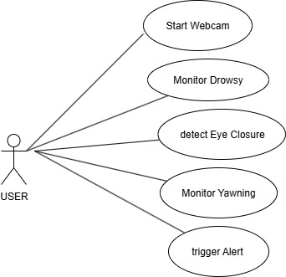
Fig.5.Usecase Diagram

VII. Results and Discussion:

1.Detection Accuracy: The system effectively identified signs of fatigue, including extended eye closure and yawning by employing accurately set EAR and MAR thresholds. Across various testing sessions, it achieved an accuracy rate between 88% and 91%. Most errors occurred when the subject moved their head quickly or wore glasses
that partially blocked facial landmarks nevertheless, the detection remained reliable and responsive overall.

2.Latency and Resource Efficiency: A significant advantage of the system was its rapid response and lightweight design. Alerts were triggered in under 200 milliseconds upon detecting signs of fatigue, providing immediate feedback. Even during continuous monitoring, CPU usage was maintained below 30% and memory usage under 100 MB, allowing real-time performance without overloading the system.

3.Observations and Limitations: During the testing phase, the system operated effectively in well-lit indoor environments with a clear view of the face. However, low light conditions and facial obstructions like glasses did have a slight effect on detection accuracy. These edge cases highlight potential areas for future improvement such as enhancing landmark stability or dynamically adjusting thresholds to better handle more challenging conditions.

4.Sample Output: During testing, the console recorded EAR and MAR values in real time, with alerts automatically triggered once the specified thresholds were exceeded. This result highlights the efficiency of the system in detecting fatigue indicators and delivering timely responses
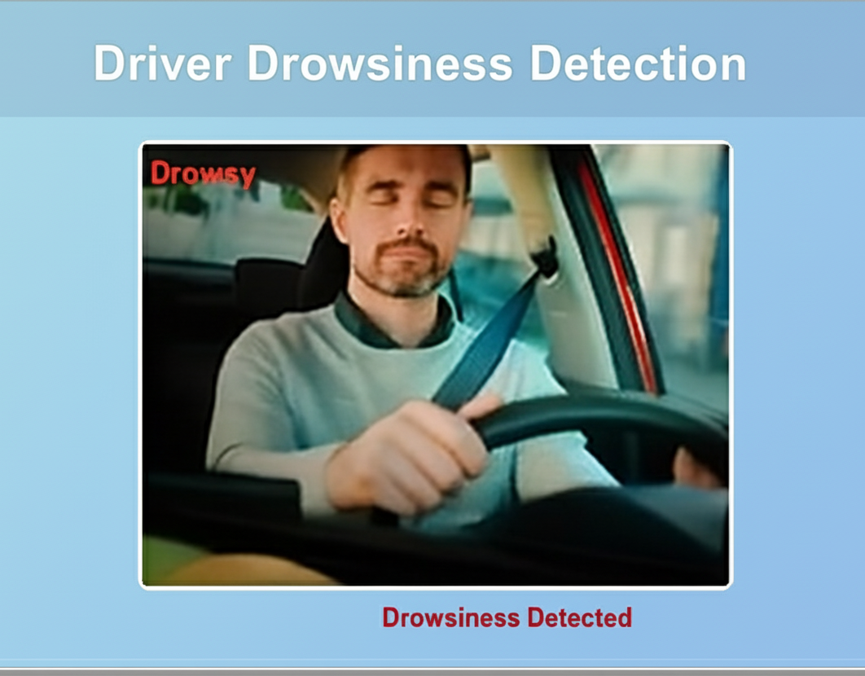
Fig.6.Sample Output

IX. Conclusion:

The objective of the project was to develop a simple, real-time system that can detect driver drowsiness using just a webcam and advanced algorithms and it has achieved that goal. By tracking eye and mouth movements through EAR and MAR thresholds, the system can identify signs of tiredness, including blinking, prolonged eyelid closure, and yawning, providing timely alerts in response.

What sets this solution apart is its lightweight and practical design. It runs entirely on CPU without needing an internet connection and performs efficiently on typical hardware, allowing easy deployment in personal cars, commercial fleets, or public transport systems. The results showed high accuracy and rapid response times, demonstrating that even a basic setup can greatly improve road safety.
These favorable results also underscore opportunities for further enhancement, especially in addressing edge cases like low-light conditions and facial obstructions. While the system performed reliably under normal circumstances, it occasionally encountered difficulties when the subject wore glasses or when ambient lighting was inadequate. Future enhancements could involve more advanced landmark tracking, adaptive thresholding, or the integration of visual data with additional metrics such as head position or heart rate. These improvements would bolster the system’s resilience and responsiveness across a wider array of real-world situations.

In conclusion, this system offers a practical, scalable approach to ensuring driver alertness thereby contributing to safer roads.

X.REFERENCES:
[1] S. Abd El-Nabi, A. F. Ibrahim, E.-S. M. El-Rabai, O. F. Hassan, N. F. Soliman, K. F. Ramadan, and W. El-Shafai, "Driver Drowsiness Detection Using Swin Transformer and Diffusion Models for Robust Image Denoising," IEEE Access, vol. 13, no. –, pp. 71880–71892, April 2025.

[2] P. K. Singh, A. Gupta, M. Upadhyay, A. Jain, M. Khari, and P. S. Lamba, "Multimodal Driver Drowsiness Detection From Video Frames," Journal of Mobile Multimedia, vol. 19, no. 2, pp. 567–586, November 2022.

[3] A.Ziryawulawo, M.Kirabo, C.Mwikirize, J.Serugunda, E. Mugume, and S. P. Miyingo, "Machine Learning Based Driver Monitoring System: A Case Study for the Kayoola EVS," South African Institute of Electrical Engineers, vol. 114, no. 2, pp. 40–47, June 2023.

[4] F. Guede-Fernández, M. Fernández-Chimeno, J. Ramos-Castro, and M. A. García-González, "Driver Drowsiness Detection Based on Respiratory Signal Analysis," IEEE Access, vol. 11, no. –, pp. 13579–13591, February 2023[&#95;{{{CITATION{{{&#95;1{](file:///C:/Users/dhars/Downloads/ppt4.pdf).

[5] M. A. Khan, T. Nawaz, U. S. Khan, A. Hamza, and N. Rashid, "IoT-Based Non-Intrusive Automated Driver Drowsiness Monitoring Framework for Logistics and Public Transport Applications to Enhance Road Safety," IEEE Access, vol. 11, no. –, pp. 122345–122360, December 2023.

[6] M. Ramzan, M. Fayyaz, A. Abid, T. J. Alahmadi, H. Nobanee, and A. Rehman, "A Novel Hybrid Approach for Driver Drowsiness Detection Using a Custom Deep Learning Model," IEEE Access, vol. 12, no. –, pp. 126866–126881, August 2024.

[7] H. A. Madni, A. Raza, L. Abualigah, R. Sehar, and N. Thalji, "Novel Transfer Learning Approach for Driver Drowsiness Detection Using Eye Movement Behaviour," IEEE Access, vol. 12, no. –, pp. 64765–64778, May2024.[&#95;{{{CITATION{{{&#95;1{](file:///C:/Users/dhars/Downloads/ppt7.pdf)

[8] A. Kolus, "A Systematic Review on Driver Drowsiness Detection Using Eye Activity Measures," IEEE Access, vol. 12, no. –, pp. 97969–97993, July 2024.
[9] S. K. Mousavikia, S.B.Ors Yalcin, E. Gholizadehazari, and M. Mousazadeh, "Instruction Set Extension of a Risc V Based SoC for Driver Drowsiness Detection," IEEE Access, vol. 10, no. –, pp. 58151–58162, June 2022.

[10] V. Vijaypriya and M. Uma, "Facial Feature-Based Drowsiness Detection With Multi-Scale Convolutional Neural Network," Department of Computational Intelligence, SRM Institute of Science and Technology, Kattankulathur, India.

[11] S. K. Mousavikia, S. B. Ors Yalcin, E. Gholizadehazari, and M. Mousazadeh, "Instruction Set Extension of a RISC-V Based SoC for Driver Drowsiness Detection," Department of Electrical Engineering, Urmia University, and Department of Electronics and Communication Engineering, Istanbul Technical University, Iran and Turkey.

